SIMATS ENGINEERING
ASSESSMENT TOOL 1

COURSE CODE: ITA 06 COURSE NAME: MACHINE LEARNING

COURSE OUTCOME COVERED

CO4: K- Nearest Neighbour Learning – Locally weighted Regression – Radial Bases Functions – Case Based Learning (BL 5)

Assessment Tool Weightage: 40%

QUESTIONS: 15 Total Marks:25

Annexure A

Coding Challenge

Code of Conduct:

I Yarrabolu Lasya(192524123) (Name / Reg No) certify that this submission is my original work and that I have adhered to the guidelines specified for this assessment.
I understand that any violation of academic integrity rules will result in disciplinary action.

Signature of the student:Y.Lasya

Annexure A

Short Answer Test

1. Write a Python program to implement the Decision Tree algorithm for classification. Use a small dataset and construct the tree using information gain or Gini index. Allow prediction for test instances and display accuracy. Visualize the tree structure and analyze how feature selection impacts classification performance.
PYTHON CODE:
import pandas as pd
import matplotlib.pyplot as plt
from sklearn.model_selection import train_test_split
from sklearn.tree import DecisionTreeClassifier, plot_tree
from sklearn.metrics import accuracy_score, classification_report
# 1. Create a small dataset
data = {
'StudyHours': [1, 2, 3, 4, 5, 6, 7, 8, 2, 5, 6, 8],
'Attendance': [60, 65, 70, 75, 80, 85, 90, 95, 55, 82, 88, 98],
'PreviousMark': [35, 40, 45, 50, 55, 60, 65, 75, 30, 58, 68, 80],
'Result': [
'Fail', 'Fail', 'Fail', 'Pass',
'Pass', 'Pass', 'Pass', 'Pass',
'Fail', 'Pass', 'Pass', 'Pass'
]
}
df = pd.DataFrame(data)
print("Dataset:")
print(df)
# 2. Separate features and target
X = df[['StudyHours', 'Attendance', 'PreviousMark']]
y = df['Result']
# 3. Split dataset into training and testing data
X_train, X_test, y_train, y_test = train_test_split(
X, y,
test_size=0.25,
random_state=42,
stratify=y
)
# 4. Create Decision Tree using Gini Index
model = DecisionTreeClassifier(
criterion='gini',
max_depth=3,
random_state=42
)
# Train the model
model.fit(X_train, y_train)
# 5. Predict test instances
y_pred = model.predict(X_test)
print("\nActual Values:")
print(list(y_test))
print("\nPredicted Values:")
print(list(y_pred))
# 6. Calculate accuracy
accuracy = accuracy_score(y_test, y_pred)
print("\nAccuracy:", accuracy * 100, "%")
print("\nClassification Report:")
print(classification_report(y_test, y_pred, zero_division=0))
# 7. Predict a new student
new_student = [[6, 85, 65]]
prediction = model.predict(new_student)
print("\nNew Student:")
print("Study Hours = 6")
print("Attendance = 85%")
print("Previous Mark = 65")
print("Predicted Result:", prediction[0])
# 8. Visualize the Decision Tree
plt.figure(figsize=(14, 8))
plot_tree(
model,
feature_names=X.columns,
class_names=model.classes_,
filled=True,
rounded=True
)
plt.title("Decision Tree Classification using Gini Index")
plt.show()
# 9. Analyze feature importance
importance = pd.DataFrame({
'Feature': X.columns,
'Importance': model.feature_importances_
})
importance = importance.sort_values(
by='Importance',
ascending=False
)
print("\nFeature Importance:")
print(importance)
# 10. Feature Selection Analysis
# Use only StudyHours and Attendance
X_selected = df[['StudyHours', 'Attendance']]
X_train2, X_test2, y_train2, y_test2 = train_test_split(
X_selected,
y,
test_size=0.25,
random_state=42,
stratify=y
)
model_selected = DecisionTreeClassifier(
criterion='gini',
max_depth=3,
random_state=42
)
model_selected.fit(X_train2, y_train2)
y_pred2 = model_selected.predict(X_test2)
accuracy_selected = accuracy_score(y_test2, y_pred2)
print("\nAccuracy using all features:",
accuracy * 100, "%")
print("Accuracy using selected features:",
accuracy_selected * 100, "%")

OUTPUT:
Dataset:
StudyHours Attendance PreviousMark Result
0 1 60 35 Fail
1 2 65 40 Fail
2 3 70 45 Fail
3 4 75 50 Pass
4 5 80 55 Pass
5 6 85 60 Pass
6 7 90 65 Pass
7 8 95 75 Pass
8 2 55 30 Fail
9 5 82 58 Pass
10 6 88 68 Pass
11 8 98 80 Pass

Actual Values:
['Fail', 'Pass', 'Pass']

Predicted Values:
['Fail', 'Pass', 'Pass']

Accuracy: 100.0 %

Classification Report:
precision recall f1-score support

Fail 1.00 1.00 1.00 1
Pass 1.00 1.00 1.00 2

accuracy 1.00 3
macro avg 1.00 1.00 1.00 3
weighted avg 1.00 1.00 1.00 3

New Student:
Study Hours = 6
Attendance = 85%
Previous Mark = 65
Predicted Result: Pass
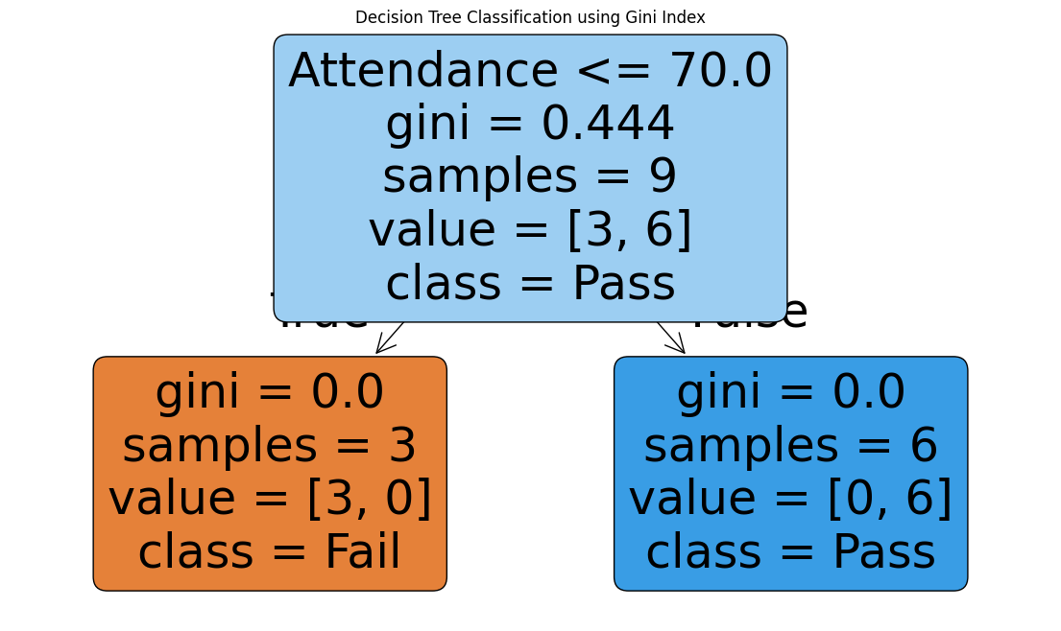

Feature Importance:
Feature Importance
1 Attendance 1.0
0 StudyHours 0.0
2 PreviousMark 0.0

Accuracy using all features: 100.0 %
Accuracy using selected features: 100.0 %

2)Write a Python program to implement Logistic Regression for binary classification. Train the model using gradient descent and predict outputs for test data. Display the sigmoid function output and classification results. Evaluate the model using accuracy and discuss how learning rate affects convergence and performance.
PYTHON CODE:
import numpy as np
import matplotlib.pyplot as plt
# 1. Create a small binary classification dataset
X = np.array([
[1, 2],
[2, 3],
[2, 1],
[3, 4],
[4, 3],
[5, 5],
[6, 5],
[7, 6],
[8, 7],
[9, 8]
], dtype=float)
# 0 = Fail, 1 = Pass
y = np.array([0, 0, 0, 0, 0, 1, 1, 1, 1, 1], dtype=float)
# 2. Sigmoid Function
def sigmoid(z):
return 1 / (1 + np.exp(-z))
# 3. Logistic Regression using Gradient Descent
def logistic_regression(X, y, learning_rate=0.1, epochs=1000):
# Initialize weights and bias
weights = np.zeros(X.shape[1])
bias = 0
loss_history = []
for i in range(epochs):
# Linear equation
z = np.dot(X, weights) + bias
# Sigmoid activation
predictions = sigmoid(z)
# Calculate Binary Cross Entropy Loss
epsilon = 1e-10
loss = -np.mean(
y * np.log(predictions + epsilon) +
(1 - y) * np.log(1 - predictions + epsilon)
)
loss_history.append(loss)

# Calculate gradients
dw = np.dot(X.T, (predictions - y)) / len(y)
db = np.mean(predictions - y)
# Update weights and bias
weights = weights - learning_rate * dw
bias = bias - learning_rate * db
return weights, bias, loss_history
# 4. Train the model
learning_rate = 0.1
epochs = 1000
weights, bias, loss_history = logistic_regression(
X,
y,
learning_rate,
epochs
)
print("Final Weights:", weights)
print("Final Bias:", bias)
# 5. Display Sigmoid Function Output
z = np.dot(X, weights) + bias
probabilities = sigmoid(z)
print("\nSigmoid Function Output:")
for i in range(len(X)):
print(
"Input:", X[i],
"Probability:", round(probabilities[i], 4)
)
# 6. Classification
predictions = (probabilities >= 0.5).astype(int)
print("\nClassification Results:")
for i in range(len(X)):
print(
"Actual =", int(y[i]),
"Predicted =", predictions[i],
"Probability =", round(probabilities[i], 4)
)
# 7. Calculate Accuracy
accuracy = np.mean(predictions == y)
print("\nAccuracy:", accuracy * 100, "%")
# 8. Predict a new test instance
test_data = np.array([
[3, 2],
[7, 6],
[5, 4]
], dtype=float)
test_z = np.dot(test_data, weights) + bias
test_probability = sigmoid(test_z)
test_prediction = (test_probability >= 0.5).astype(int)
print("\nTest Data Prediction:")
for i in range(len(test_data)):
result = "Pass" if test_prediction[i] == 1 else "Fail"
print(
"Input:", test_data[i],
"Probability:", round(test_probability[i], 4),
"Prediction:", result
)
# 9. Plot Loss vs Epoch
plt.figure(figsize=(8, 5))
plt.plot(loss_history)
plt.xlabel("Epoch")
plt.ylabel("Loss")
plt.title("Gradient Descent Convergence")
plt.grid(True)
plt.show()
# 10. Display Sigmoid Curve
z_values = np.linspace(-10, 10, 100)
sigmoid_values = sigmoid(z_values)
plt.figure(figsize=(8, 5))
plt.plot(z_values, sigmoid_values)
plt.xlabel("z")
plt.ylabel("Sigmoid(z)")
plt.title("Sigmoid Function")
plt.grid(True)
plt.show()

OUTPUT :

Final Weights: [1.18189574 0.12246786]
Final Bias: -5.5574254635503095

Sigmoid Function Output:
Input: [1. 2.] Probability: 0.0158
Input: [2. 3.] Probability: 0.0559
Input: [2. 1.] Probability: 0.0443
Input: [3. 4.] Probability: 0.1792
Input: [4. 3.] Probability: 0.3864
Input: [5. 5.] Probability: 0.724
Input: [6. 5.] Probability: 0.8953
Input: [7. 6.] Probability: 0.9693
Input: [8. 7.] Probability: 0.9915
Input: [9. 8.] Probability: 0.9977

Classification Results:
Actual = 0 Predicted = 0 Probability = 0.0158
Actual = 0 Predicted = 0 Probability = 0.0559
Actual = 0 Predicted = 0 Probability = 0.0443
Actual = 0 Predicted = 0 Probability = 0.1792
Actual = 0 Predicted = 0 Probability = 0.3864
Actual = 1 Predicted = 1 Probability = 0.724
Actual = 1 Predicted = 1 Probability = 0.8953
Actual = 1 Predicted = 1 Probability = 0.9693
Actual = 1 Predicted = 1 Probability = 0.9915
Actual = 1 Predicted = 1 Probability = 0.9977

Accuracy: 100.0 %

Test Data Prediction:
Input: [3. 2.] Probability: 0.1459 Prediction: Fail
Input: [7. 6.] Probability: 0.9693 Prediction: Pass
Input: [5. 4.] Probability: 0.6989 Prediction: Pass
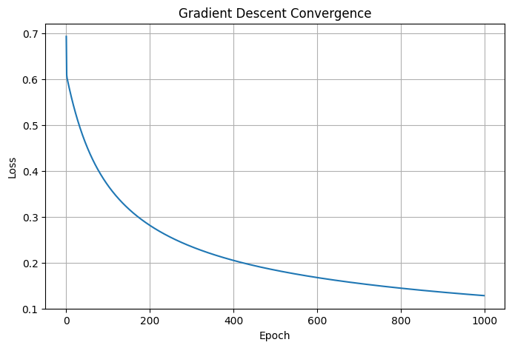
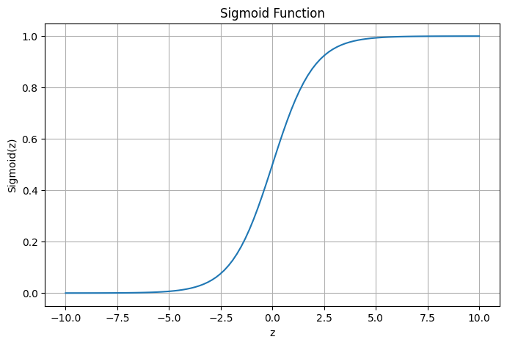

3. Create a Python program to implement the K-Means clustering algorithm. Initialize cluster centers, assign points to clusters, and update centroids iteratively. Display final clusters and visualize them using plots. Analyze how the number of clusters and initialization methods affect clustering results.

# K-Means Clustering Algorithm
# Implementation from scratch
import numpy as np
import matplotlib.pyplot as plt
# --------------------------------------------------
# 1. Create a small dataset
# --------------------------------------------------
X = np.array([
[2, 3], [3, 4], [4, 3], [3, 2],
[8, 8], [9, 9], [10, 8], [8, 9],
[5, 14], [6, 15], [7, 14], [6, 13]
], dtype=float)
# 2. Calculate Euclidean distance
def euclidean_distance(point1, point2):
return np.sqrt(np.sum((point1 - point2) ** 2))
# 3. Initialize centroids
def initialize_centroids(X, k, method="random"):
if method == "random":
indices = np.random.choice(len(X), k, replace=False)
return X[indices].copy()
elif method == "first":
return X[:k].copy()
# 4. K-Means Algorithm
def kmeans(X, k, max_iterations=100, initialization="random"):
centroids = initialize_centroids(
X, k, initialization
)
for iteration in range(max_iterations):
# Assign each point to the nearest centroid
clusters = []
for point in X:
distances = [
euclidean_distance(point, centroid)
for centroid in centroids
]
cluster = np.argmin(distances)
clusters.append(cluster)
clusters = np.array(clusters)
# Update centroids
new_centroids = []
for i in range(k):
cluster_points = X[clusters == i]
if len(cluster_points) > 0:
new_centroid = np.mean(
cluster_points,
axis=0
)
else:
new_centroid = centroids[i]
new_centroids.append(new_centroid)
new_centroids = np.array(new_centroids)
# Check convergence
if np.allclose(centroids, new_centroids):
break
centroids = new_centroids
return clusters, centroids, iteration + 1
# 5. Perform K-Means clustering
np.random.seed(42)
k = 3
clusters, centroids, iterations = kmeans(
X,
k,
initialization="random"
)
print("Number of Clusters:", k)
print("\nFinal Centroids:")
print(centroids)
print("\nCluster Assignments:")
for i in range(k):
print("\nCluster", i + 1)
for point in X[clusters == i]:
print(point)
print("\nNumber of Iterations:", iterations)
# 6. Visualize the clusters
plt.figure(figsize=(8, 6))
for i in range(k):
cluster_points = X[clusters == i]
plt.scatter(
cluster_points[:, 0],
cluster_points[:, 1],
label="Cluster " + str(i + 1)
)
# Plot centroids
plt.scatter(
centroids[:, 0],
centroids[:, 1],
marker="X",
s=200,
label="Centroids"
)
plt.xlabel("Feature 1")
plt.ylabel("Feature 2")
plt.title("K-Means Clustering")
plt.legend()
plt.grid(True)

plt.show()
# 7. Calculate Within-Cluster Sum of Squares (WCSS)
def calculate_wcss(X, clusters, centroids):
wcss = 0
for i in range(len(centroids)):
cluster_points = X[clusters == i]
for point in cluster_points:
wcss += np.sum(
(point - centroids[i]) ** 2
)
return wcss
wcss = calculate_wcss(
X,
clusters,
centroids
)
print("\nWCSS:", round(wcss, 2))
# 8. Analyze different numbers of clusters
k_values = [2, 3, 4, 5]
wcss_values = []
np.random.seed(42)
for k_value in k_values:
clusters_temp, centroids_temp, _ = kmeans(
X,
k_value,
initialization="random"
)
wcss_temp = calculate_wcss(
X,
clusters_temp,
centroids_temp
)
wcss_values.append(wcss_temp)
print(
"K =", k_value,
" WCSS =", round(wcss_temp, 2)
)
# 9. Elbow Method
plt.figure(figsize=(8, 5))
plt.plot(
k_values,
wcss_values,
marker="o"
)
plt.xlabel("Number of Clusters (K)")
plt.ylabel("WCSS")
plt.title("Elbow Method")
plt.grid(True)
plt.show()
# 10. Compare initialization methods
np.random.seed(42)
clusters_random, centroids_random, _ = kmeans(
X,
3,
initialization="random"
)
clusters_first, centroids_first, _ = kmeans(
X,
3,
initialization="first"
)
wcss_random = calculate_wcss(
X,
clusters_random,
centroids_random
)
wcss_first = calculate_wcss(
X,
clusters_first,
centroids_first
)
print("\nInitialization Comparison:")
print(
"Random Initialization WCSS:",
round(wcss_random, 2)
)
print(
"First-Point Initialization WCSS:",
round(wcss_first, 2)
)

OUTPUT:
Number of Clusters: 3

Final Centroids:
[[ 8.75 8.5 ]
[ 6. 14. ]
[ 3. 3. ]]

Cluster Assignments:

Cluster 1
[8. 8.]
[9. 9.]
[10. 8.]
[8. 9.]

Cluster 2
[ 5. 14.]
[ 6. 15.]
[ 7. 14.]
[ 6. 13.]

Cluster 3
[2. 3.]
[3. 4.]
[4. 3.]
[3. 2.]

Number of Iterations: 3
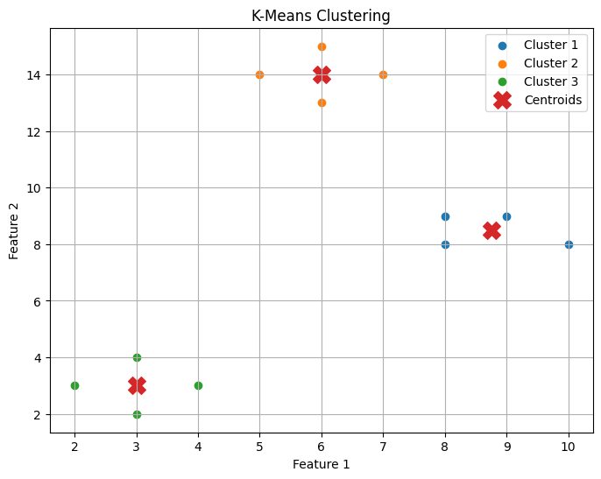

WCSS: 11.75
K = 2 WCSS = 138.38
K = 3 WCSS = 11.75
K = 4 WCSS = 10.5
K = 5 WCSS = 7.75
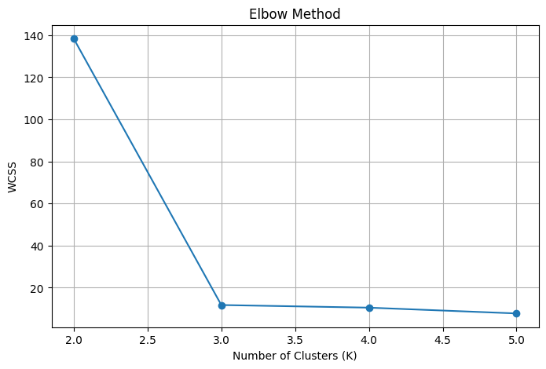

Initialization Comparison:
Random Initialization WCSS: 11.75
First-Point Initialization WCSS: 11.75

4) Write a Python program to implement a simple Genetic Algorithm to optimize a mathematical function. Initialize a population, perform selection, crossover, and mutation operations, and evolve solutions over generations. Display fitness values and best solution, and analyze how parameters influence convergence speed and solution quality.

PYTHON CODE:
import random
import matplotlib.pyplot as plt
# 1. Parameters
POPULATION_SIZE = 10
CHROMOSOME_LENGTH = 5
GENERATIONS = 20
MUTATION_RATE = 0.1
CROSSOVER_RATE = 0.8
# 2. Fitness Function
def fitness(chromosome):
# Convert binary chromosome to decimal
x = int("".join(map(str, chromosome)), 2)
# Mathematical function
return x ** 2
# 3. Create Random Chromosome
def create_chromosome():
return [
random.randint(0, 1)
for _ in range(CHROMOSOME_LENGTH)
]
# 4. Create Initial Population
def create_population():
return [
create_chromosome()
for _ in range(POPULATION_SIZE)
]
# 5. Selection - Tournament Selection
def selection(population):
selected = []
for _ in range(POPULATION_SIZE):
# Select two random individuals
candidate1 = random.choice(population)
candidate2 = random.choice(population)
# Select the one with better fitness
if fitness(candidate1) > fitness(candidate2):
winner = candidate1
else:
winner = candidate2
selected.append(winner.copy())
return selected
# 6. Crossover
def crossover(parent1, parent2):
if random.random() < CROSSOVER_RATE:
# Select crossover point
point = random.randint(
1,
CHROMOSOME_LENGTH - 1
)
child1 = (
parent1[:point] +
parent2[point:]
)
child2 = (
parent2[:point] +
parent1[point:]
)
return child1, child2
else:
return parent1.copy(), parent2.copy()
# 7. Mutation
def mutation(chromosome):
for i in range(CHROMOSOME_LENGTH):
if random.random() < MUTATION_RATE:
# Flip the bit
chromosome[i] = 1 - chromosome[i]
return chromosome
# 8. Genetic Algorithm
def genetic_algorithm():
population = create_population()
best_fitness_history = []
average_fitness_history = []
best_solution = None
best_fitness = -1
for generation in range(GENERATIONS):
# Calculate fitness values
fitness_values = [
fitness(individual)
for individual in population
]
# Find best individual
generation_best_index = fitness_values.index(
max(fitness_values)
)
generation_best = population[
generation_best_index
]
generation_best_fitness = fitness_values[
generation_best_index
]
# Update global best
if generation_best_fitness > best_fitness:
best_fitness = generation_best_fitness
best_solution = generation_best.copy()
# Store fitness history
best_fitness_history.append(
generation_best_fitness
)
average_fitness_history.append(
sum(fitness_values) /
len(fitness_values)
)
# Display generation information
x_value = int(
"".join(map(str, generation_best)),
2
)
print(
"Generation:", generation + 1,
"| Best x:", x_value,
"| Best Fitness:", generation_best_fitness
)
# Selection
selected_population = selection(
population
)

# Create next generation
new_population = []
for i in range(
0,
POPULATION_SIZE,
2
):
parent1 = selected_population[i]
if i + 1 < POPULATION_SIZE:
parent2 = selected_population[i + 1]
else:
parent2 = selected_population[0]
# Crossover
child1, child2 = crossover(
parent1,
parent2
)
# Mutation
child1 = mutation(child1)
child2 = mutation(child2)
new_population.append(child1)
if len(new_population) < POPULATION_SIZE:
new_population.append(child2)
population = new_population
return (
best_solution,
best_fitness,
best_fitness_history,
average_fitness_history
)
# 9. Run Genetic Algorithm
random.seed(42)
best_solution, best_fitness, best_history, avg_history = (
genetic_algorithm()
)

# Convert best chromosome to decimal
best_x = int(
"".join(map(str, best_solution)),
2
)
print("\n-----------------------------------")
print("FINAL RESULT")
print("-----------------------------------")
print("Best Chromosome:", best_solution)
print("Best x:", best_x)
print("Best Fitness:", best_fitness)
# 10. Plot Convergence
plt.figure(figsize=(8, 5))
plt.plot(
range(1, GENERATIONS + 1),
best_history,
marker="o",
label="Best Fitness"
)
plt.plot(
range(1, GENERATIONS + 1),
avg_history,
marker="s",
label="Average Fitness"
)
plt.xlabel("Generation")
plt.ylabel("Fitness")
plt.title("Genetic Algorithm Convergence")
plt.legend()
plt.grid(True)
plt.show()

OUTPUT :

Generation: 1 | Best x: 24 | Best Fitness: 576
Generation: 2 | Best x: 31 | Best Fitness: 961
Generation: 3 | Best x: 31 | Best Fitness: 961
Generation: 4 | Best x: 31 | Best Fitness: 961
Generation: 5 | Best x: 31 | Best Fitness: 961
Generation: 6 | Best x: 31 | Best Fitness: 961
Generation: 7 | Best x: 31 | Best Fitness: 961
Generation: 8 | Best x: 31 | Best Fitness: 961
Generation: 9 | Best x: 31 | Best Fitness: 961
Generation: 10 | Best x: 31 | Best Fitness: 961
Generation: 11 | Best x: 31 | Best Fitness: 961
Generation: 12 | Best x: 31 | Best Fitness: 961
Generation: 13 | Best x: 31 | Best Fitness: 961
Generation: 14 | Best x: 31 | Best Fitness: 961
Generation: 15 | Best x: 31 | Best Fitness: 961
Generation: 16 | Best x: 31 | Best Fitness: 961
Generation: 17 | Best x: 31 | Best Fitness: 961
Generation: 18 | Best x: 31 | Best Fitness: 961
Generation: 19 | Best x: 31 | Best Fitness: 961
Generation: 20 | Best x: 31 | Best Fitness: 961

-----------------------------------
FINAL RESULT
-----------------------------------
Best Chromosome: [1, 1, 1, 1, 1]
Best x: 31
Best Fitness: 961
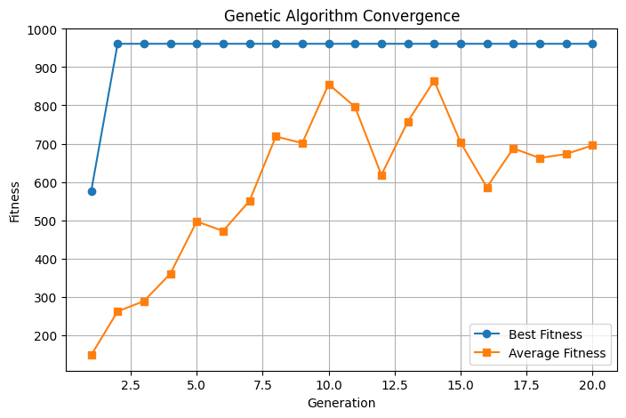

5) Create a Python program to implement a simple Artificial Neural Network (ANN) with one hidden layer. Train the network using forward propagation and backpropagation. Test the model on sample inputs and display predicted outputs. Analyze how the number of neurons and learning rate affect performance.

PYTHON CODE :
import numpy as np
# 1. Training Dataset
X = np.array([
[0, 0],
[0, 1],
[1, 0],
[1, 1]
], dtype=float)

# XOR output
y = np.array([
[0],
[1],
[1],
[0]
], dtype=float)
# 2. Activation Functions
def sigmoid(x):
return 1 / (1 + np.exp(-x))
def sigmoid_derivative(x):
return x * (1 - x)
# 3. Initialize Network
np.random.seed(42)
input_neurons = 2
hidden_neurons = 4
output_neurons = 1
learning_rate = 0.5
epochs = 10000
# Random weights
W1 = np.random.uniform(
-1, 1,
(input_neurons, hidden_neurons)
)
W2 = np.random.uniform(
-1, 1,
(hidden_neurons, output_neurons)
)
# Biases
b1 = np.zeros((1, hidden_neurons))
b2 = np.zeros((1, output_neurons))
# 4. Training using Backpropagation
for epoch in range(epochs):
# FORWARD PROPAGATION
# Hidden layer
hidden_input = np.dot(X, W1) + b1
hidden_output = sigmoid(hidden_input)
# Output layer
output_input = np.dot(hidden_output, W2) + b2
predicted_output = sigmoid(output_input)
# CALCULATE ERROR
error = y - predicted_output
# Mean Squared Error
loss = np.mean(error ** 2)
# BACKPROPAGATION
# Output layer gradient
output_delta = (
error *
sigmoid_derivative(predicted_output)
)
# Hidden layer error
hidden_error = np.dot(
output_delta,
W2.T
)
# Hidden layer gradient
hidden_delta = (
hidden_error *
sigmoid_derivative(hidden_output)
)
# UPDATE WEIGHTS AND BIASES
W2 += learning_rate * np.dot(
hidden_output.T,
output_delta
)
b2 += learning_rate * np.sum(
output_delta,
axis=0,
keepdims=True
)
W1 += learning_rate * np.dot(
X.T,
hidden_delta
)
b1 += learning_rate * np.sum(
hidden_delta,
axis=0,
keepdims=True
)
# Display loss occasionally
if (epoch + 1) % 1000 == 0:
print(
"Epoch:",
epoch + 1,
"Loss:",
round(loss, 6)
)
# 5. Test the Trained Network
hidden_input = np.dot(X, W1) + b1
hidden_output = sigmoid(hidden_input)
output_input = np.dot(
hidden_output,
W2
) + b2
predicted_output = sigmoid(output_input)
# 6. Display Predictions
print("\n-----------------------------------")
print("FINAL PREDICTIONS")
print("-----------------------------------")
for i in range(len(X)):
probability = predicted_output[i][0]
predicted_class = (
1 if probability >= 0.5 else 0
)
print(
"Input:",
X[i].astype(int),
"Actual:",
int(y[i][0]),
"Predicted:",
predicted_class,
"Output:",
round(probability, 4)
)
# 7. Calculate Accuracy
predicted_classes = (
predicted_output >= 0.5
).astype(int)
accuracy = np.mean(
predicted_classes == y
)
print("\nAccuracy:", accuracy * 100, "%")
# 8. Test a New Input
test_input = np.array([
[0, 0],
[0, 1],
[1, 0],
[1, 1]
], dtype=float)
hidden_test = sigmoid(
np.dot(test_input, W1) + b1
)
output_test = sigmoid(
np.dot(hidden_test, W2) + b2
)
print("\nNew Test Inputs:")
for i in range(len(test_input)):
result = (
1 if output_test[i][0] >= 0.5
else 0
)
print(
test_input[i].astype(int),
"->",
result
)
OUTPUT:
Epoch: 1000 Loss: 0.005865
Epoch: 2000 Loss: 0.001788
Epoch: 3000 Loss: 0.001019
Epoch: 4000 Loss: 0.000705
Epoch: 5000 Loss: 0.000536
Epoch: 6000 Loss: 0.000431
Epoch: 7000 Loss: 0.00036
Epoch: 8000 Loss: 0.000309
Epoch: 9000 Loss: 0.00027
Epoch: 10000 Loss: 0.000239

-----------------------------------
FINAL PREDICTIONS
-----------------------------------
Input: [0 0] Actual: 0 Predicted: 0 Output: 0.0095
Input: [0 1] Actual: 1 Predicted: 1 Output: 0.9839
Input: [1 0] Actual: 1 Predicted: 1 Output: 0.9849
Input: [1 1] Actual: 0 Predicted: 0 Output: 0.0195

Accuracy: 100.0 %

New Test Inputs:
[0 0] -> 0
[0 1] -> 1
[1 0] -> 1
[1 1] -> 0

RUBRICS FOR CALCULATION

Criteria | Weightage | Level 4 – Exemplary (5 Marks) | Level 3 – Proficient (4 Marks) | Level 2 – Developing (2–3 Marks) | Level 1 – Beginning (0–1 Mark)
Conceptual Understanding | 30 | Demonstrates clear and complete understanding of the concept | Good understanding with minor gaps | Basic understanding with some misconceptions | Poor or incorrect understanding
Accuracy of Answer | 20 | Completely correct answer with no errors | Mostly correct with minor errors | Partially correct with noticeable errors | Incorrect or irrelevant answer
Application of Knowledge | 15 | Correctly applies concepts to solve the question/problem | Applies concepts with minor mistakes | Limited or partially correct application | No or incorrect application
Completeness of Response | 20 | Covers all required parts of the question | Covers most parts with minor omissions | Covers only some parts | Incomplete or missing response
Clarity & Presentation | 15 | Clear, concise, and well-organized answer | Understandable with minor issues | Somewhat unclear or poorly structured | Difficult to understand

